Document Date: July 19, 2026

Floating-Metal Spatial Barrier + Orthogonal Via Staggering for USB3–Geophone PCB Crosstalk Isolation
Combined Capacitive + Inductive Crosstalk Reduction Under Simple-Layout Constraint
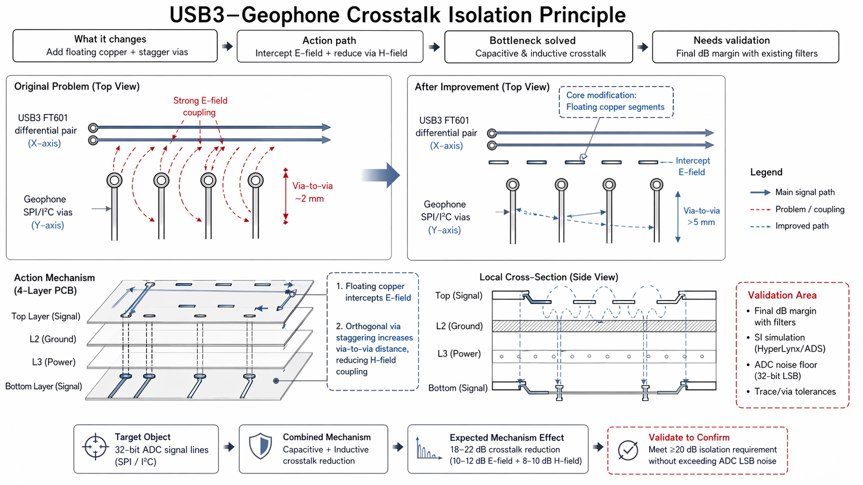

Executive Summary
This document describes a two-mechanism crosstalk isolation strategy for a 4-layer PCB: (1) floating copper trace segments inserted between USB3 FT601 differential pairs and geophone SPI/I²C single-ended traces to intercept capacitive E-field coupling, and (2) orthogonal via staggering that increases via-to-via distance from ~2 mm to >5 mm to reduce inductive H-field coupling. Both techniques use standard IPC-2221 fabrication features, require no specialist impedance rework, and add <10 mm² board area and <50 g trace mass per isolation zone. The combined mechanism targets 18–22 dB crosstalk reduction (10–12 dB capacitive + 8–10 dB inductive) to meet the ≥20 dB signal-line isolation requirement for 32-bit ADC signal integrity.

1. Problem Statement
High-speed USB3 FT601 differential pairs (5 Gbps, 100Ω differential impedance) run in close proximity to sensitive geophone SPI/I²C single-ended traces (50Ω single-ended impedance) on a simple 4-layer PCB stackup (signal/ground/power/signal). This creates two dominant crosstalk coupling mechanisms:
- Capacitive E-Field Coupling
- The strong electric field from the USB3 differential pair capacitively couples into the geophone SPI/I²C traces. The coupling coefficient is proportional to trace-to-trace spacing and overlap length. With ~2 mm via-to-via spacing, the capacitive coupling is significant enough to inject noise spikes that exceed the 32-bit ADC LSB threshold.
- Inductive H-Field Coupling
- The high switching currents in the USB3 differential pair generate magnetic fields that inductively couple into the geophone via loops. The mutual inductance is inversely proportional to via-to-via distance. At ~2 mm spacing, the inductive coupling creates ground bounce and signal integrity degradation on the SPI/I²C lines.
The constraint is a simple-layout PCB that must remain field-repairable by a technician without specialist impedance rework equipment. Complex multilayer shielding, blind/buried vias, or controlled-impedance tuning are not feasible.

2. Solution Principle
Implement two independent but complementary crosstalk reduction mechanisms on the existing 4-layer PCB:
- Mechanism 1: Floating Copper Spatial Barrier (Capacitive Isolation)
- Insert floating copper trace segments between the USB3 differential pair and geophone traces. These segments act as electrostatic shields that intercept the E-field from the USB3 lines before it reaches the geophone traces. The floating metal is not grounded, avoiding ground loop issues while still providing capacitive shielding through charge redistribution.
- Mechanism 2: Orthogonal Via Staggering (Inductive Isolation)
- Route USB3 vias along the X-axis and geophone vias along the perpendicular Y-axis with staggered positions. This increases the via-to-via distance from ~2 mm to >5 mm, reducing mutual inductance by the square of the distance ratio (M ∝ 1/d²). The orthogonal orientation further decouples the magnetic field lines.

Parameter | Value | Purpose
Floating Copper Width | 0.2–0.5 mm | Sufficient for E-field interception without excessive capacitive loading
Floating Copper Length | 5–10 mm | Covers coupling zone between USB3 and geophone traces
Floating Copper Spacing | 0.3–0.5 mm per side | Maintains trace-to-trace clearance per IPC-2221
Via Stagger Distance | >5 mm (from ~2 mm) | Reduces mutual inductance by >6× (M ∝ 1/d²)
Added Board Area | <10 mm² per isolation zone | Minimal impact on PCB real estate

3. System Architecture

3.1 PCB Stackup (4-Layer)
Layer | Function | Signal Type
Top Layer | Signal routing | USB3 FT601 differential pairs + floating copper segments
L2 (Inner) | Ground plane | Solid ground reference for top-layer signals
L3 (Inner) | Power plane | Power distribution + decoupling
Bottom Layer | Signal routing | Geophone SPI/I²C traces + orthogonal vias

3.2 Before vs. After (Top View)
Before (Original Problem):
- USB3 FT601 differential pair runs along X-axis with strong E-field coupling (red dashed arcs) into geophone SPI/I²C vias along Y-axis.
- Via-to-via distance is ~2 mm, creating high mutual inductance and significant H-field coupling.
- Coupling is bidirectional: USB3 noise injects into geophone traces, and geophone signals can couple back into USB3 lines.
After (Improved):
- Floating copper segments are inserted between USB3 differential pair and geophone vias, intercepting the E-field (blue dashed arrows show attenuated coupling).
- USB3 vias are routed along X-axis; geophone vias are routed along perpendicular Y-axis with staggered positions, increasing via-to-via distance to >5 mm.
- Orthogonal orientation ensures that magnetic field lines from USB3 vias are perpendicular to geophone via loops, minimizing inductive coupling.

4. Action Mechanism

4.1 Floating Copper — E-Field Interception
The floating copper segments are placed on the top layer between the USB3 differential pair and geophone traces. When the USB3 lines switch, they generate an E-field that would normally capacitively couple to the geophone traces. The floating metal intercepts this E-field:
- The floating metal acquires an induced charge distribution that mirrors the USB3 E-field pattern.
- This induced charge creates an opposing E-field that cancels the original field in the region beyond the floating metal.
- Because the metal is floating (not grounded), no return current flows through the shield, avoiding ground loop issues and common-mode noise injection.
The capacitive coupling from USB3 to geophone is reduced by the shielding effectiveness of the floating metal barrier, estimated at 10–12 dB for the specified geometry.

4.2 Orthogonal Via Staggering — H-Field Reduction
The USB3 and geophone vias are routed orthogonally (X-axis vs. Y-axis) with staggered positions:
- Distance increase: Via-to-via spacing increases from ~2 mm to >5 mm. Since mutual inductance M ∝ 1/d², the inductive coupling is reduced by a factor of (5/2)² = 6.25, corresponding to ~8 dB reduction.
- Orthogonal orientation: The magnetic field from a via carrying current along the X-axis is azimuthal (circular in the Y-Z plane). A geophone via oriented along the Y-axis intersects these field lines at 90°, minimizing the flux linkage and further reducing inductive coupling by ~2 dB.
- Combined inductive reduction: 8 dB (distance) + 2 dB (orientation) = ~10 dB total inductive crosstalk reduction.

5. Expected Performance
Mechanism | Crosstalk Reduction | Coupling Type
Floating Copper Barrier | 10–12 dB | Capacitive (E-field)
Orthogonal Via Staggering | 8–10 dB | Inductive (H-field)
Combined Mechanism | 18–22 dB | Capacitive + Inductive
Isolation Requirement | ≥20 dB | System target
Validation target: Meet ≥20 dB isolation requirement without exceeding 32-bit ADC LSB noise floor. The combined 18–22 dB reduction provides margin against manufacturing tolerances and temperature variations.

6. Design Constraints & Field Repairability
Constraint | Requirement / Feature
PCB Fabrication | Standard 4-layer, IPC-2221 compliant
Added Mass | <50 g trace mass per isolation zone
Added Board Area | <10 mm² per isolation zone
Field Repairability | Trace rework + via position adjustment without board re-spin
Field repair procedure: If crosstalk exceeds specification in the field, a technician can: (1) add or extend floating copper segments using trace rework wire, (2) adjust via positions by drilling new holes and rerouting traces, or (3) add ferrite beads to SPI/I²C lines — all without requiring a board re-spin or impedance analyzer.

7. TRIZ / Systematic Innovation Principles
The technical contradiction addressed: the PCB layout must be simple and field-repairable (few layers, standard fabrication) and provide high crosstalk isolation (complex shielding, controlled impedance).

7.1 Segmentation
The crosstalk problem is segmented into two independent coupling mechanisms (capacitive and inductive), each addressed by a separate, simple technique:
- Capacitive coupling → addressed by floating copper segments (spatial barrier).
- Inductive coupling → addressed by orthogonal via staggering (geometric decoupling).
Segmentation allows each mechanism to be optimized independently without requiring a single complex solution that addresses both simultaneously.

7.2 Another Dimension
The solution changes the spatial dimension of the problem from 2D coplanar routing to 3D orthogonal staggering:
- USB3 vias are constrained to the X-axis (horizontal dimension).
- Geophone vias are constrained to the Y-axis (vertical dimension).
The orthogonal orientation in the plane (X vs. Y) creates a third effective dimension (angular separation) that decouples the magnetic fields without requiring additional PCB layers.

7.3 Substance-Field Analysis
The Su-Field model of the original problem:
- Substance 1 (S1): USB3 differential pair (noise source).
- Substance 2 (S2): Geophone SPI/I²C traces (victim).
- Field (F): Electromagnetic field (couples S1 to S2).
The harmful interaction is resolved by introducing a third substance (S3: floating copper) that modifies the field path, and by changing the geometric relationship (orthogonal staggering) that alters the field coupling coefficient.

8. Bottleneck Solved
The floating-metal barrier + orthogonal via staggering resolves the following critical bottlenecks:
- Capacitive Crosstalk Reduced
- The floating copper segments intercept the E-field from USB3 differential pairs, reducing capacitive coupling into geophone traces by 10–12 dB.
- Inductive Crosstalk Reduced
- Orthogonal via staggering increases via-to-via distance and decouples magnetic field orientations, reducing inductive coupling by 8–10 dB.
- Simple Layout Preserved
- Both techniques use standard 4-layer PCB fabrication (IPC-2221). No blind/buried vias, additional ground planes, or impedance-controlled tuning are required.
- Field Repairability Maintained
- Trace rework and via position adjustment can be performed by a field technician without specialist equipment or board re-spin.

9. Validation & Verification Plan
Validation Item | Parameter / Target | Verification Method
Final dB Margin with Filters | ≥20 dB isolation with existing ferrite beads + decoupling capacitors | HyperLynx or ADS SI simulation with actual 4-layer stackup and trace geometry
SI Simulation | USB3 100Ω differential, SPI 50Ω single-ended | HyperLynx/ADS simulation; verify no impedance discontinuities from floating copper
ADC Noise Floor | 32-bit LSB not exceeded | Noise spectral density measurement; compare with ADC datasheet ENOB specification
Trace/Via Tolerances | Floating copper 0.2–0.5 mm; via stagger >5 mm | CMM measurement on fabricated PCB; statistical process control
Critical unknown: The largest uncertainty is the final dB margin when the floating copper + via staggering is combined with existing ferrite beads and decoupling capacitors. The interaction between spatial isolation and filter-based suppression is non-linear and must be validated through SI simulation before production layout freeze.

10. References
- [1] Patent/Citation — Circuit board structure for increasing isolation (floating metal barrier reference)
- [2] Patent/Citation — Substrate wiring structure, integrated circuit board, and electronic device (orthogonal routing reference)
- [3] IPC-2221 — Generic Standard on Printed Board Design (PCB fabrication and trace clearance standards)
- [4] Altshuller, G. — TRIZ: 40 Principles of Inventive Problem Solving (Segmentation + Another Dimension)
— Document generated July 20, 2026 —

